Student Name: Yinsheng Dong

Student Number: 11148648

NSID: yid164

CMPT360 Assignment 4

Question 1.

Reduce the maximum flow problem.

In this question, the flow network N which all of the edges have capacity equal to one is given.

The integer k is given. We want to find the maximum flow in N which is reduced by deleting k of the edges from N.

Solution:

To solve this question, we need to declare:

Assume that N (V, E) which V represents the vertices (nodes) and E represents the edges in flow network N.

Let n be the value of the maximum flow of network N.

We know that the result cannot be less than n – k because the edges capacity equal to one.

According to the Max-Flow Min-Cut Theorem. Then we got 2 conditions:

1. If n <= k, then we can just remove all edges in that cut, and disconnecting s and t in N, then the maximum flow will be 0.
2. If n > k, then we need to remove k edges from the min-cut, we create a cut with value n-k

According the statement above, we can claim that the min-cut in the new graph has the value of n’ = max (0, n-k). Then based on Max-Flow Min-Cut Theorem, the max-flow of new graph is n’.

The Algorithm Code: (in next page)



Time Complexity:

This algorithm’s running time is polynomial because the minimal s – t cut represents polynomial time, and to remove the k edge needs linear in k time.

Question 2.

Kleinberg and Tardos page 416 #6

The Ergonomic Architecture Commission problem.

The question has given multiple variables which are fixtures, switches and walls. We want to use these variables to determine if they are ergonomic or not.

Algorithm design:



In this algorithm, I used 2 loops. The first one is for creating the bipartite graph which contains pairs of switches and fixture, and I used the walls to determine if the pair should add to the bipartite graph or not. The second loop is for checking the floor plan by looping the bipartite graph.

The complexity of this algorithm:

The first loop will cost O(n^2 \* m) which n is the number of switches and fixtures, and m is the number of walls.

The second loop will cost O(n) because it runs sequentially.

Then the totally time complexity is O(n^2 \* m)

Question 3.

Kleinberg and Tardo page 419 #9

The problem for dealing with natural disasters and other crises.

To solve this question, we could build a flow network

Solution algorithm:

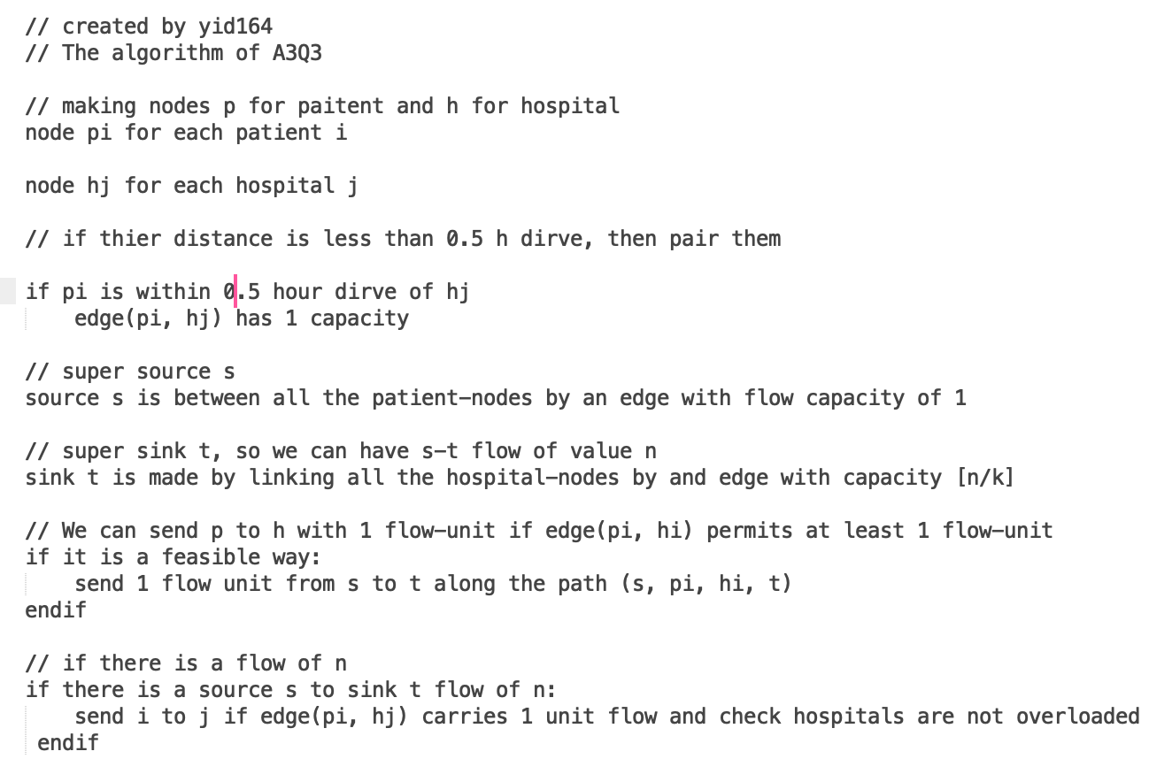

About this algorithm, this approach of sending patients to hospitals will not break the capacity limitation of edges.

Time complexity of this graph algorithm of max-flow problem:

Nodes (patients and hospitals): it will take O (n + k)

Edges: it will take O (nk)